

software design and archetecture

LAB REPORT 9



Topic: Deployment Diagram

QUESTION 1:

Library Management System (LMS) is library management software for monitoring and controlling the transactions in a library. LMS gives us complete information about the library and the daily transactions done in a Library. LMS maintains the details of books available in the library. LMS mainly focuses on basic operations in a library like adding a new member, new books and updating information on existing books. LMS also provides the facility of search books, search members, borrow books and return books. Following systems are required to deploy LMS system in a real environment. Local Consoles Computers for login and search purposes by users, librarian and vendors. Library LAN Server interconnects all the systems to the Database. Internet provide access to Vendors to supply the requested books by the Librarian Vendor Server maintains the records of the requests made by the librarian and books provided to the library. Question:

* Draw the UML Deployment diagram for the system mentioned above.

ANSWER:

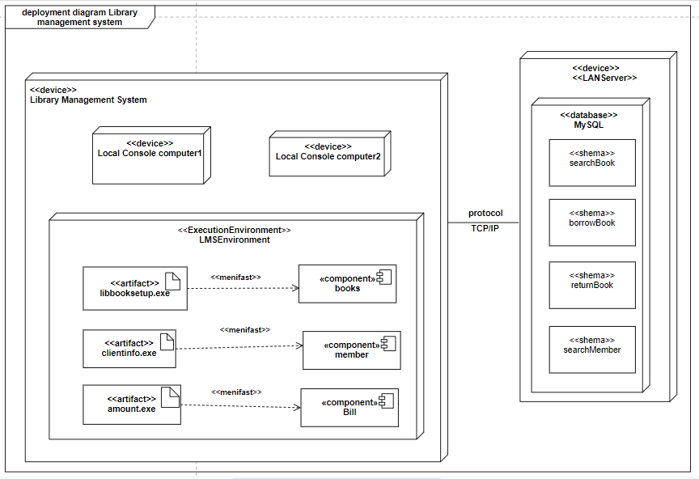

QUESTION 2:

Consider any software you have developed so far and create deployment diagram for it

ANSWER:

